Gleneagles Golf Course
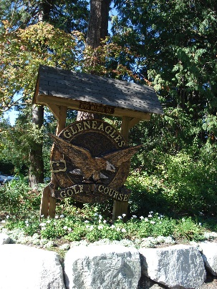
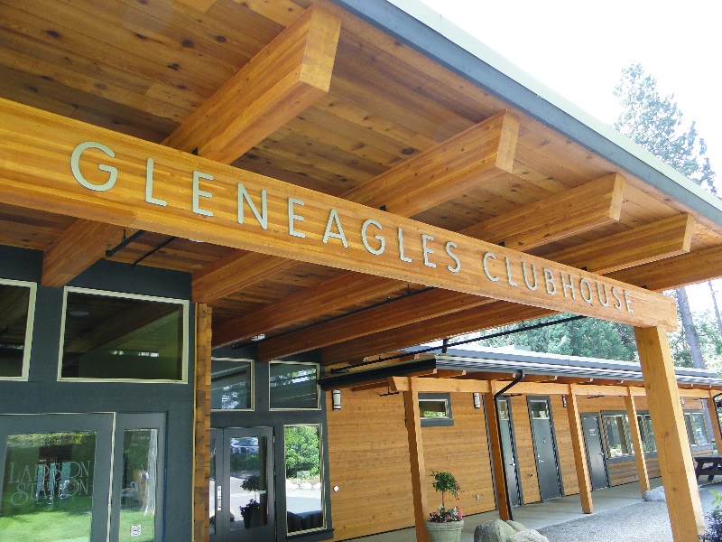

Open since 1927 Gleneagles golf course is greater Vancouver’s fifth oldest continuously operated public golf course. In 2008/2009 the District of West Vancouver undertook a major restoration and addition to the Gleneagles buildings. Tamlin was honoured to be chosen to work on this commercial project with Tom Bowen of KMBR architects. The challenge was restoring the Great Hall, which is a cedar milled log heritage building, and adding on a Golf Services Building that flowed seamlessly into the heritage building. Using our expertise in milled log and timber frame structures we were able to achieve this. Like Tamlin, KMBR has a commitment to functional and sustainable building design so working with them on this project was a pleasure.
Part of this project also involved determining if any of the cedar or douglas fir that needed to be removed from the existing building could be remanufactured and re-used on the project. If re-use on the project was not an option Tamlin coordinated with West Vancouver Parks to determine if the materials would be suitable for another West Vancouver project. Fortunately we were able to re-use many materials including some of the original siding which was sandblasted for re-use. This sustainable and eco-friendly concept was used throughout the project.
While a new build or even a renovation is quite simple, a restoration of a heritage site is a little more complex. Tamlin’s senior designers and project managers worked with the architect, Tom Bowen from KMBR, to formulate a plan that made sure the restoration was done according to the Heritage Societies’ requirements, but also brought the building up to current code. Great care was taken in restoring the cedar logs in particular. Fortunately we had some photos of the Great Hall when it was built in the early 1950s, so we were able to restore it as closely to when it was originally built as possible.
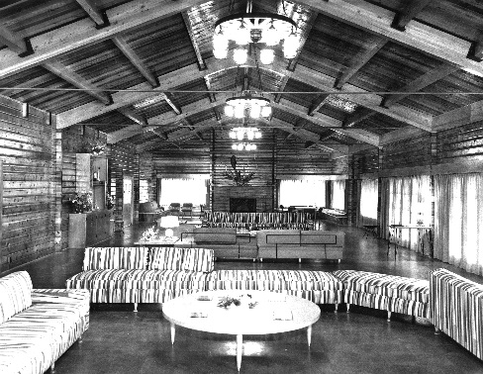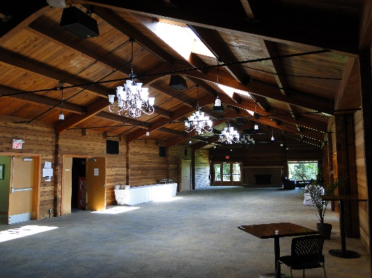
Great Hall 1952 Restored Great Hall
The addition included a lobby area connecting the Great Hall and the rest of the addition, which includes washrooms, a restaurant, and pro shop and also an additional banquet space off the Great Hall. Coastal douglas fir and western red cedar was used through-out the building inside and out, for a perfect marriage of old and new. Tamlin’s timber manufacturing and on site building team worked to keep the project moving forward in a reasonable timeline with as little disruption to the day to day business of the golf course as possible.

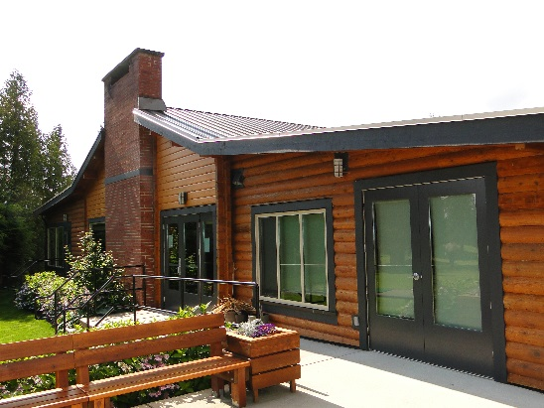
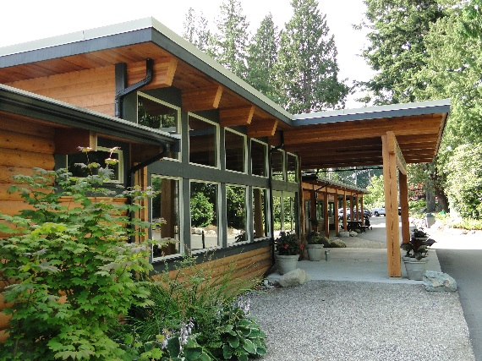
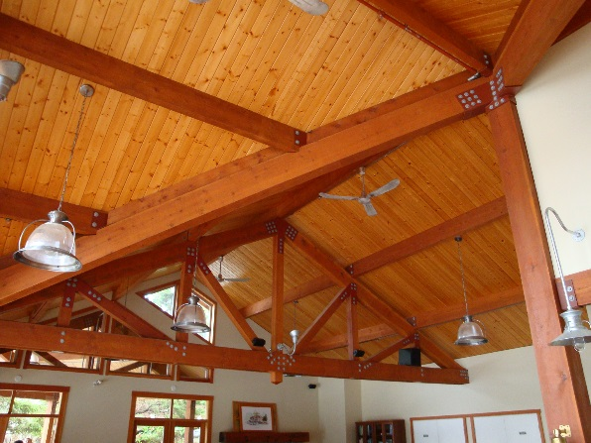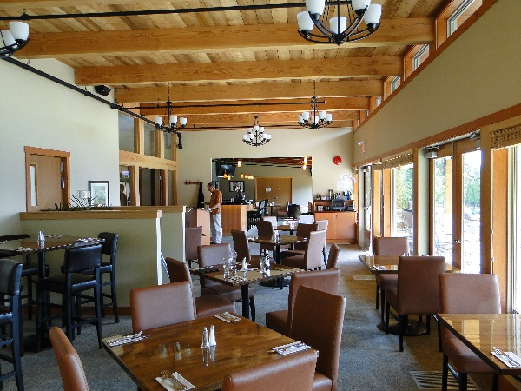

Gleneagles golf course was rated one of Canada’s best 9 hole courses in 2014 by Canadian Golf Course magazine. ”It offers you a complete golfing experience from the first tee off to the last green. With spectacular views, a beautiful clubhouse and a variety of amenities, you will definitely want to come back for another round soon”

